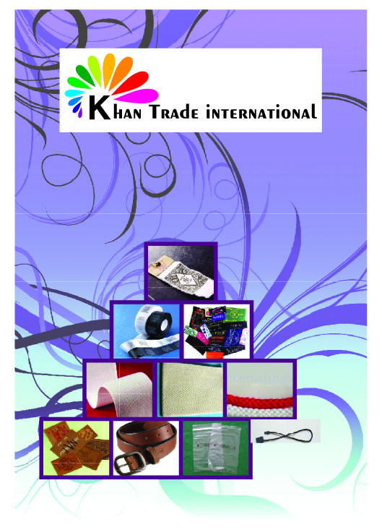
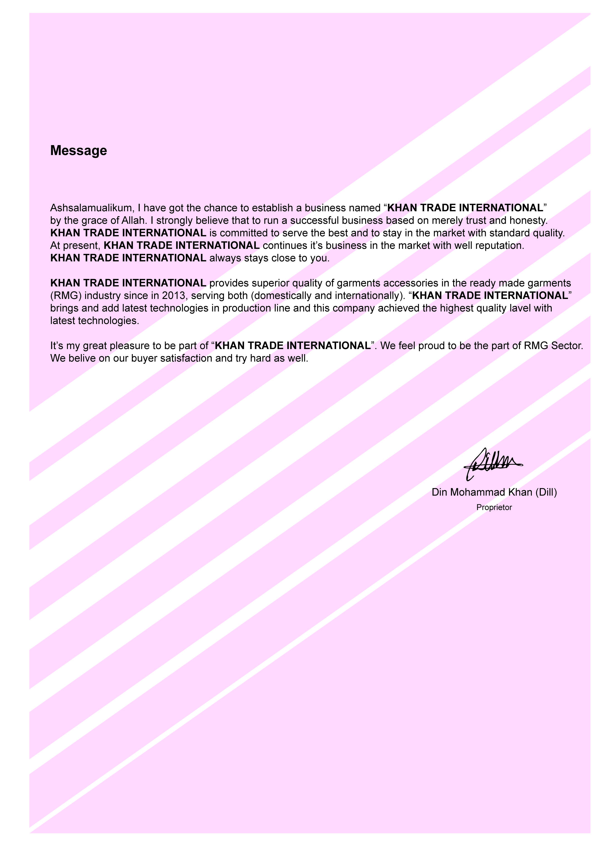
Mission
* Excellent customer service.
* Good team work with positive attitude.
* Offering outstanding quality accessories.
* Faster delivery.
* Effective and professional service.
Office & Contact: House # 32, Arambagh (Ground Floor),Motijheel C/A, Dhaka-1000, Bangladesh.
Phone: +88027195416, +88-01721-002498,
E-mail: khantradeint13@gmail.com.
Bank Name: Agroni Bank, Green Road Brach, Dhaka, Bangladesh.
Product Line
* Sticker.
* Label.
* Woven Label.
* Hangtag/ Printed Barcode/ Sewing Tag & all offset paper printing.
* Printed Poly Bag (BOPP, PP, PE, PE-HD, PE-LD).
* PVC Poly Bag.
* Plastic package (M-clip/ C-clip/ Collar Stand/ Collar bone/ Butterfly).
* Leather Items (Patch & Belt).
* Elastic. All Elastic
* Twill Tape.
* Woven Belt
* Draw cord & Dostring etc.

However, if any buyer wants us to locate the best source for their require to get the best things, we do that as well.

Daily Production Capacity:

Item Total/Day
* Sticker 50000 Dz
* Hangtag/Barcode/sewing tag 20000 Dz
* PVC poly 420 Dz
* Printed Care Label 26000 Dz
* Plastic String 10000 dz
* Twill Tape 20000 Yds
* Woven Belt 3000 Yds
* Leather Patch 1000 Dz
* Leather Belt 180 Dz
* Elastic 10000 Yds
* Woven Label 900/24 Hours dzn
* Draw Cord 10000 yds
* Dostring 40000 yds

Favorit Paper, Sticker & Board Printing Machine
Model-1971( Made in German)
Color-1
Productivity – 12000 pcs 19X26” hour
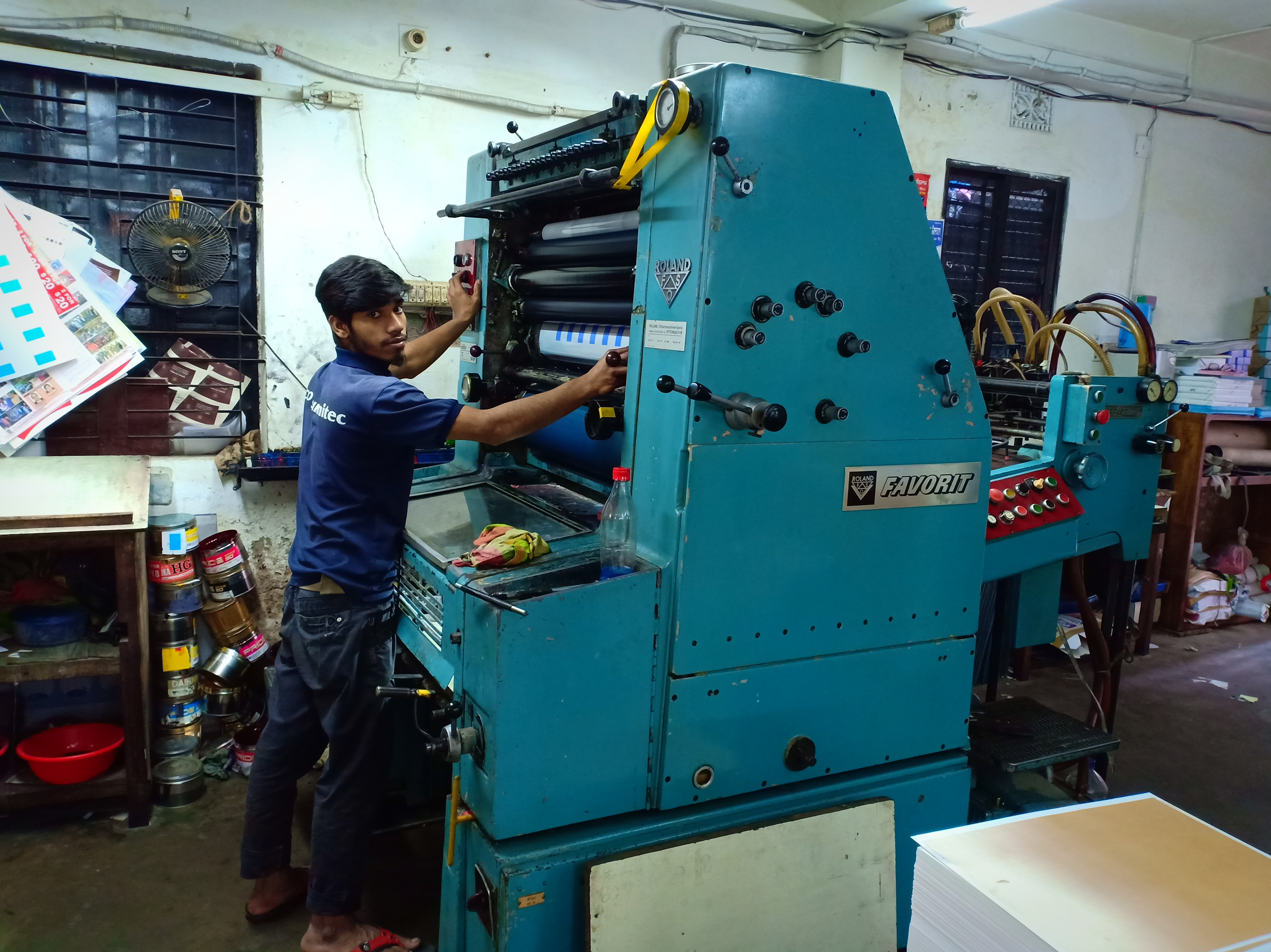

Heidelberg EMO Paper, Sticker & Board Printing Machine
Model-86 (Made in German)
Color-1
Productivity – 9000 pcs 18X25.25” hour
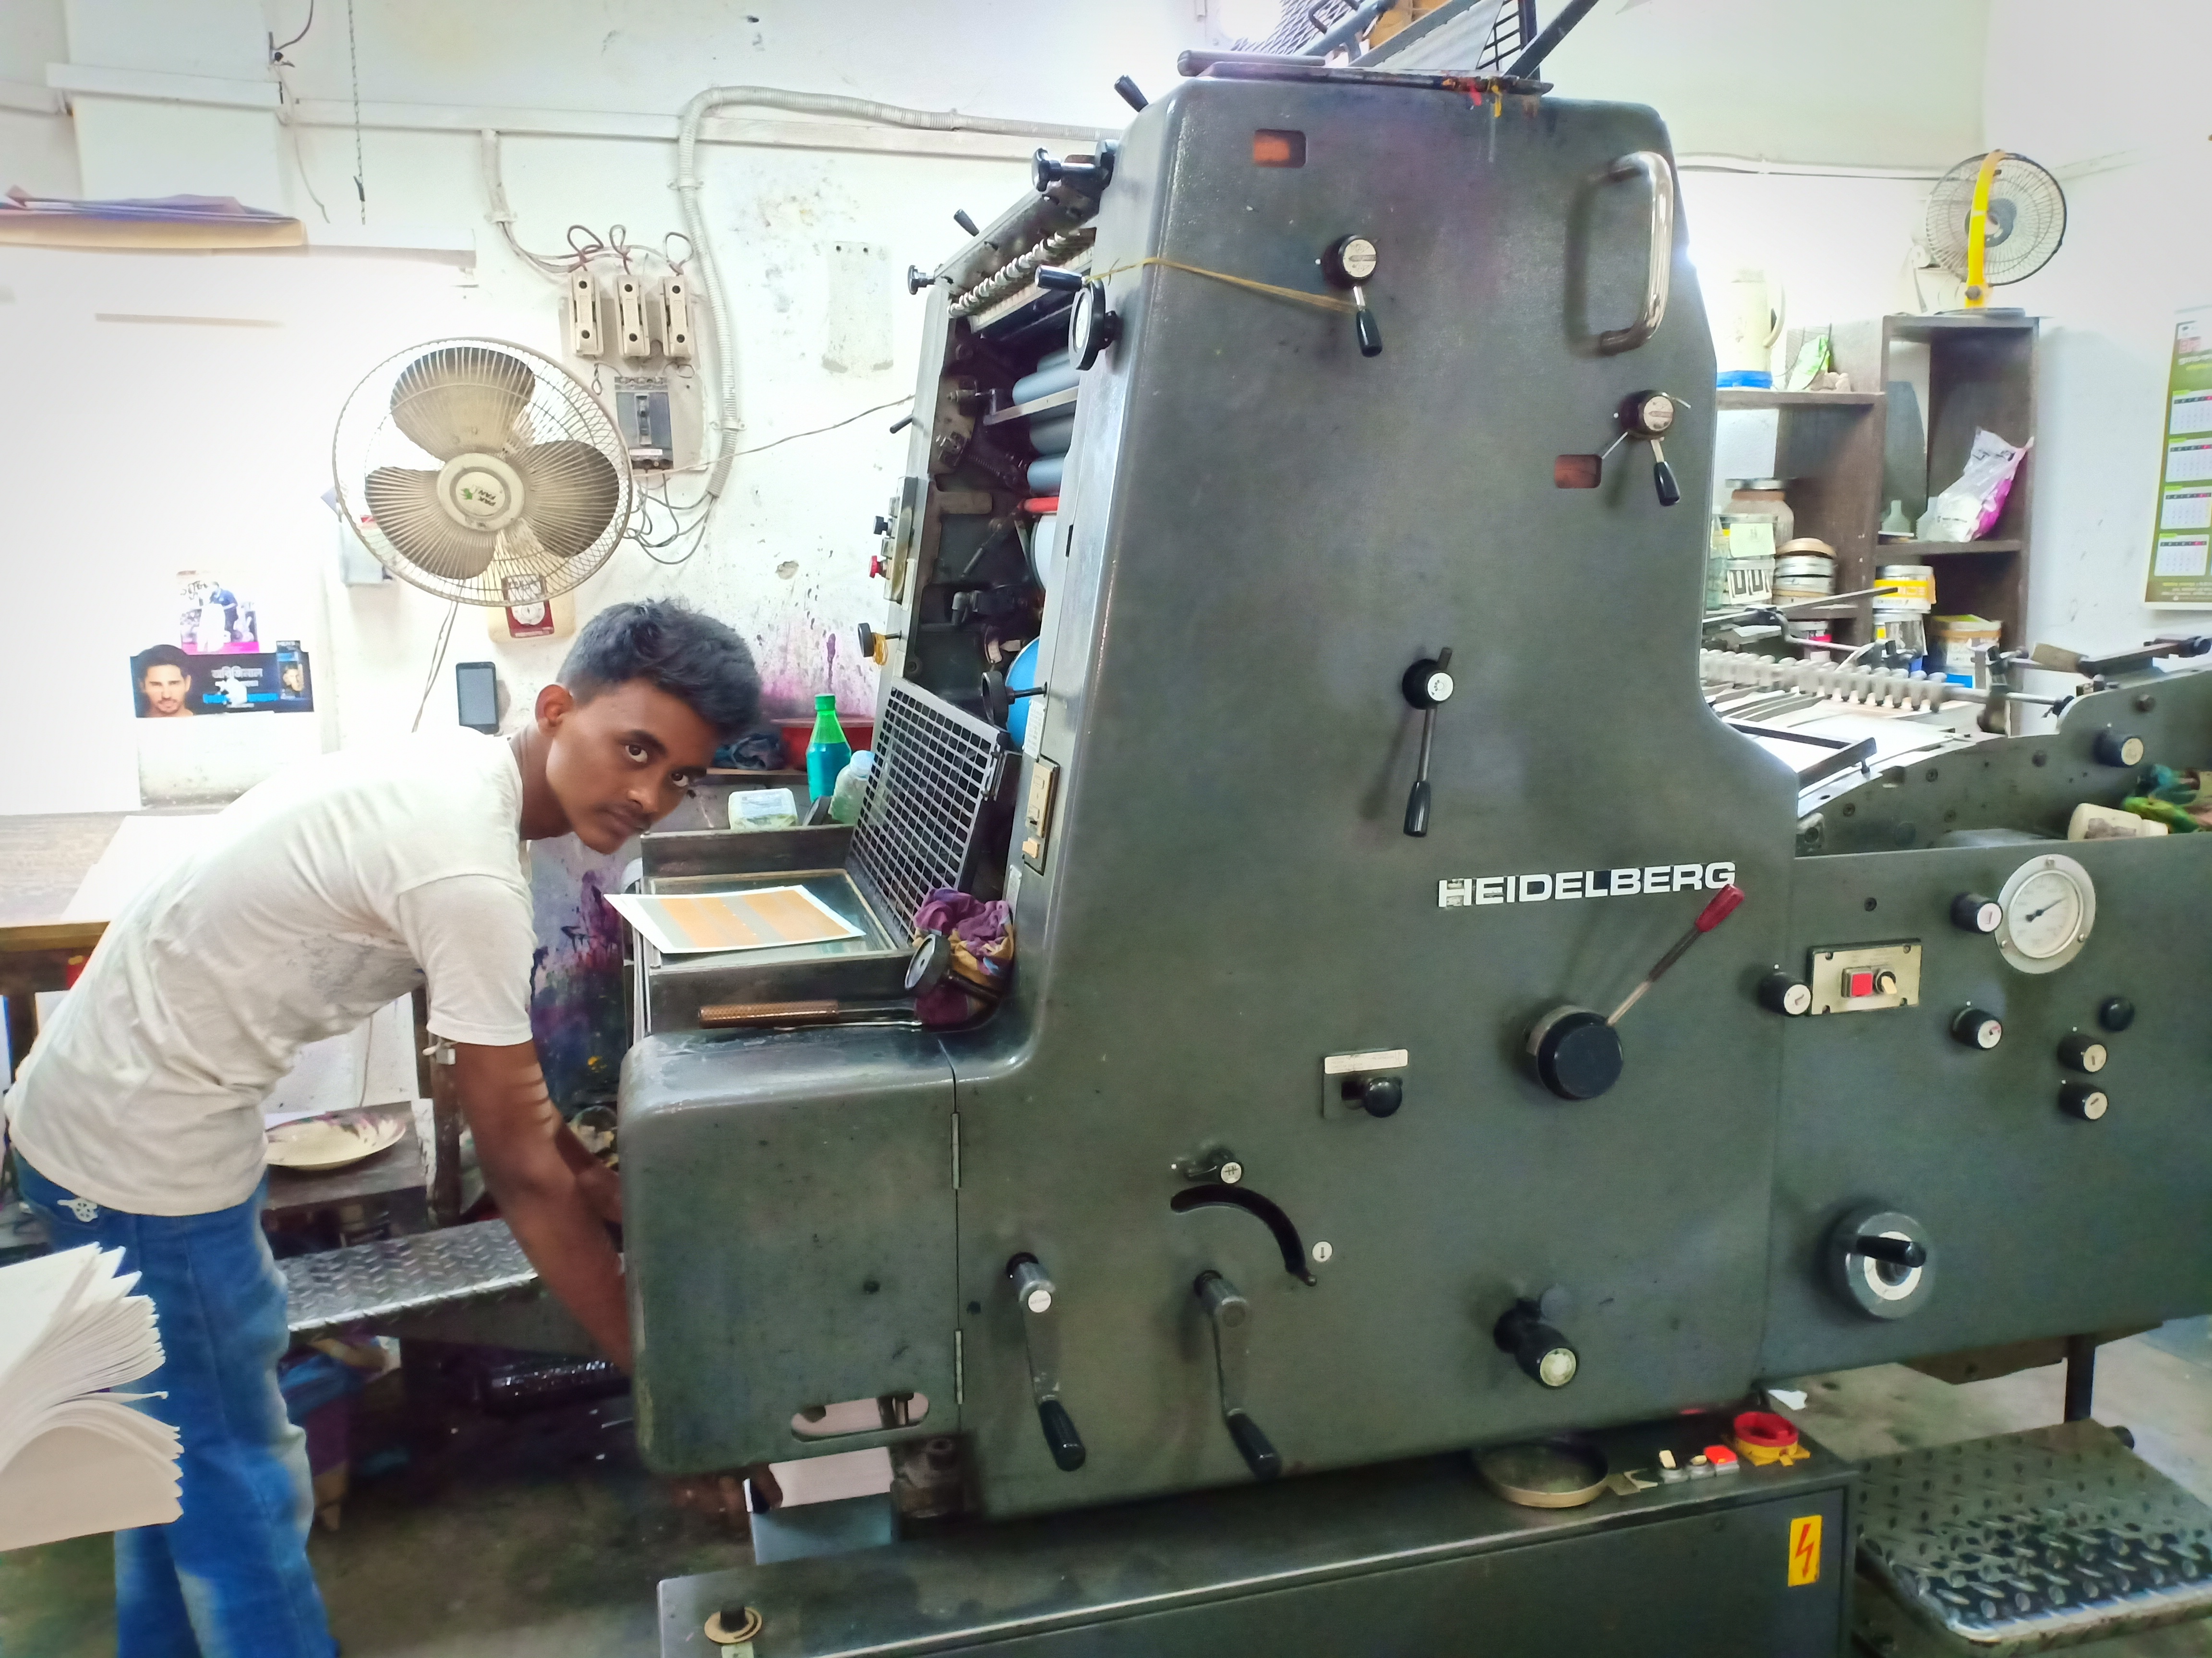

Paper, Sticker & Board (Die Cuting Machine )
Model-96(Made in China)
Color-1
Productivity – 9000 pcs 19X26” hour
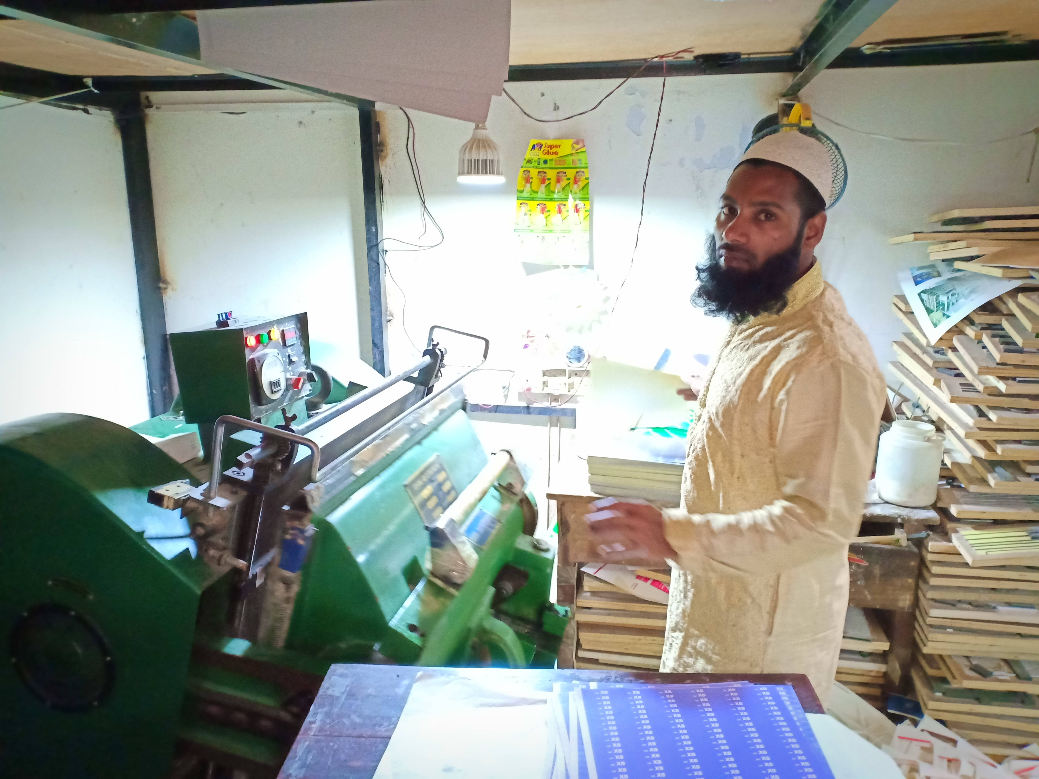

Printing Machine
* Roland Favorite 1 Pcs 19” X 26’’ 1 Colour (Made by Germany).
* Cord Heidelberg 86 Model 1 Pcs 18” X 25.25” (Made by Germany).
* China Paper Cutting Machine 1 Pcs 18’’ X 25.25, (Made by China).
* Dyi Cutting Machine 2 Pcs 19’’ X 26’’ (Made by China).
* Pasting Machine 1 Pcs (Made in Bangladesh).
* Lamination Machine 1 Pcs (Made in China).
* Eyelet & Auto Punch Machine 2 Pcs (Made in China).
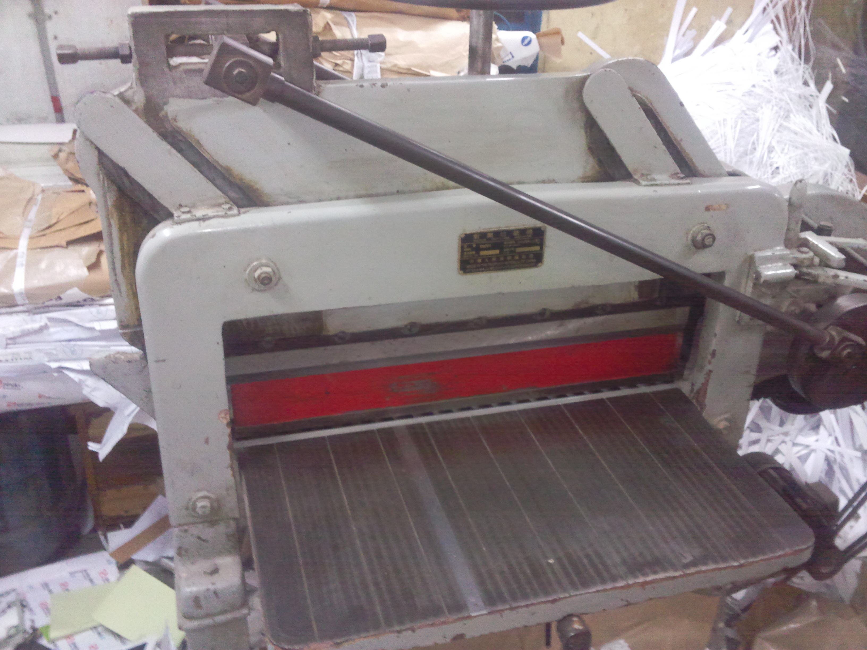
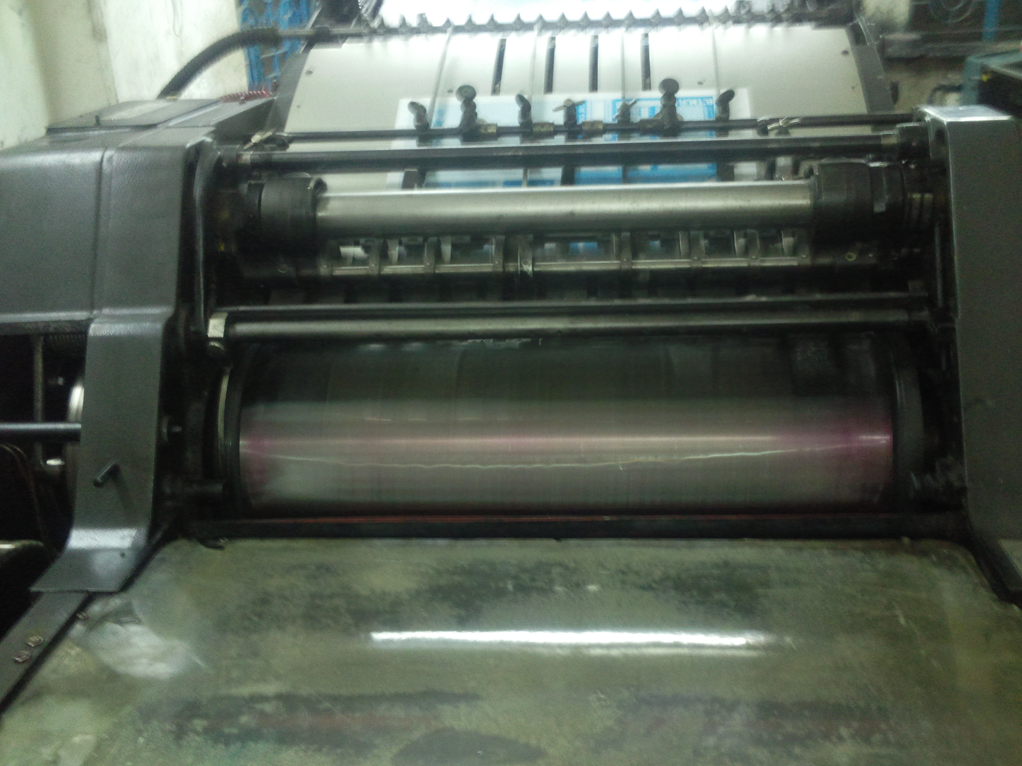

Khan Trade International CODE OF CONDUCT:
Employment policies: Khan Trade International abides by the principle that decisions on hiring, salary, benefits, advancement, termination or retirement are based solely on the ability of an individual to do the job.
Forced Labor: Khan Trade International does not use forced labor in any form: - prison, indentured, bonded or otherwise.
Child Labor: Khan Trade International does not employ any person below the age of 18 to produce apparel, accessories or equipment.
Wages & Salary: Khan Trade International provides each employee at least the minimum wage, or higher and provides each employee a clear, written accounting for every pay period.
Safety Policy: To provide adequate control of the health and safety risks arising from our work activities. To consult with our employees on matters of health and safety. Maintain safe plant, equipment and building.
Environmental Policy: We are strictly comply environmental laws and regulation of the governments of Bangladesh and to produce without hampering the environment and considering to the health and safety of our people and as well as our employees. OUR COMPANY SLOGAN "KEEP OUR ENVIRONMENT GREEN"

PRINCIPLES
* To deal fairly, openly and honestly with all employees, customers and suppliers.
* To always obtain the best value from the resources available.
MOTTO
* To avoid any dislocation and misunderstanding between inter department of factory and office.
* To maintain good healthy and harmonious inter personal relationship inside the organization.
* Maintain good Working Environment for better productivity.

Our Valued Customers

* Beximco (Yellow)
* Afiya Knitwear
* Atla
* PRIMARK
* ALDI
* BEST SELLER
* BEST MOUNTAIN
* COLIN’S
* COMA
* DISTRA
* DKC
* JACK & JONES
* LANDMARK
* MASCOT
* SRG
* TEMA
* ZARA

Terms & Conditions:
* Payment : By 100% irrevocable letter of credit at 90 days sight from the date of negotiation.
* Delivery: From factory to customers ware house.

